# Lab 21

Instructor: Sidra Khatoon

E-mail: skhatoon[@uit.edu](mailto:ad@uit.edu)

# Objective

# The objective of lab is implementing SharedPreferences to store simple key-value pairs.

**Student Information**

|  |  |
| --- | --- |
| **Student Name** |  |
| **Student ID** |  |
| **Date** |  |

**Assessment**

|  |  |
| --- | --- |
| **Marks Obtained** |  |
| **Remarks** |  |
| **Signature** |  |

# Objective

# The objective of lab is implementing SharedPreferences to store simple key-value pairs.

# Instructions

You have to perform the following tasks yourselves. Raise your hand if you face any difficulty in understanding and solving these tasks. **Plagiarism** is an abhorrent practice and you should not engage in it.

# How to Submit?

Submit lab work using Teams.

# How to Use Shared Preferences in Flutter

# What is SharedPreferences?

SharedPreferences is only used to store the user's small amount of data within the application, such as settings and data (not too much; if too much, then a database is required).

SharedPreferences in Flutter are kept in XML format. It is also compatible with iOS and Android.

Assume you want to store a small value (likely a flag) that you want to be able to access later when a user opens the application. Shared preference then takes effect.

For small-value storage, we do not use SQLite since doing so requires writing complex code and supporting classes.

Shared Preferences is a tool used to store data locally on the user’s device. The data that can be stored can be a string, integer, Boolean, double, or list. Shared Preferences is often used to store data that is temporary or not too sensitive, such as login tokens, application language, or user settings.

# Why use Shared Preferences?

Here are several reasons to use Shared Preferences:

* Data stored in Shared Preferences will not be lost when the application is uninstalled or updated.
* Shared Preferences can be accessed from anywhere in the application.
* Shared Preferences is relatively easy to use.

**How to use Shared Preferences in Flutter**

To use Shared Preferences in Flutter, you need to add the shared_preferences package to your project. You can do this by running the following command in the terminal:



Once the package is added, you can create an instance of SharedPreferences by using the getInstance() method.

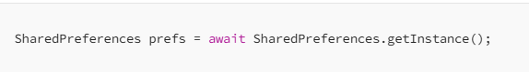

To store data in Shared Preferences, you can use the setString(), setInt(), setBool(), setDouble(), or setStringList() methods.

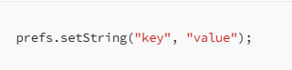

First we build basic UI for app in which we have one text field and button. There will text widget which show the stored value.

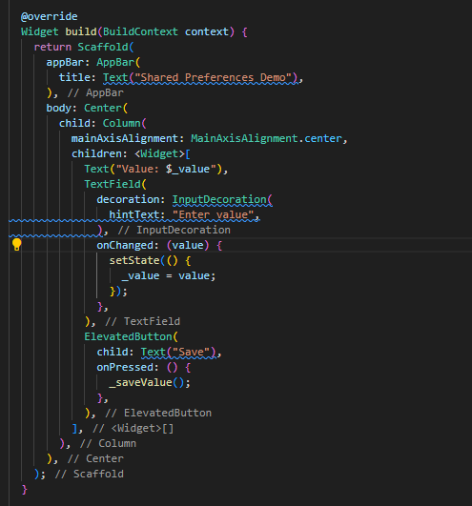

To store the value and key we have to initialize these variable:

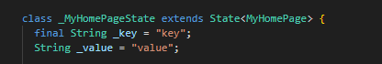

Now we write the function _savedValue to save the value.

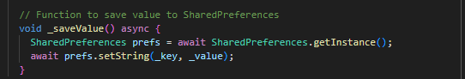

To get the saved data we have to write the function:

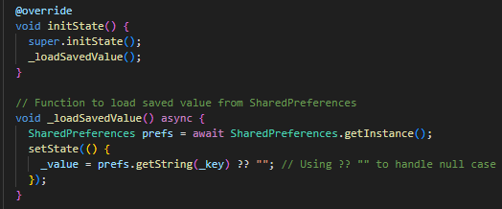

# Assessment:

Create a simple app like this and store one more value of email with help TextField and show this email locally.